R. Reports Menu: 4. Valuation Report

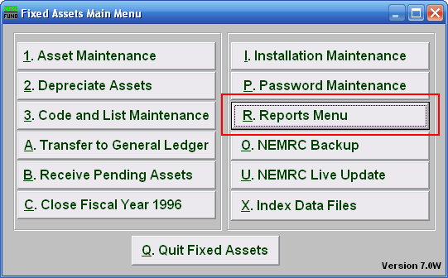
Click on “R. Reports Menu” from the Main Menu and the following window will appear:

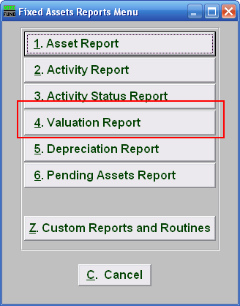
Click on “4. Valuation Report” from the Reports Menu and the following window will appear:
Valuation Report
Data ranges and grouping

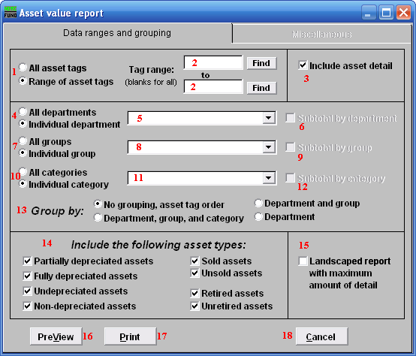
- All asset tags OR Range of asset tags: Select whether you want the report to be for All asset tags or a Range of asset tags.

- Tag range: If you chose Range of asset tags, this field will become available for you to enter the Asset tag or you can click on the “Find” button and select from the drop down menu, then enter the Asset tag you wish to end with OR leave blank for all.

- Include asset detail: Check off this box if you wish to show asset detail in your report.

- All departments OR Individual department: Select whether you want the report to be for All departments or an Individual department.

- Selector: If you chose Individual department, click on the drop down arrow and select from the table.
- Subtotal by department: If you chose 4 All departments, AND you click on 13 Group by: Department, Department and group OR Department, group and category, this option becomes available to you. Click on this to Subtotal by department.

- All groups OR Individual group: Select whether you want the report to be for All groups or an Individual group.

- Selector: If you chose Individual group, click on the drop down arrow and select from the table.

- Subtotal by group: If you chose 7 All groups, AND you click on 13 Group by: Department, Department and group OR Department, group and category, this option becomes available to you. Click on this to Subtotal by group.

- All categories OR Individual categories: Select whether you want the report to be for All categories or an Individual category.

- Selector: If you chose Individual category, click on the drop down arrow and select from the table.

- Subtotal by category: If you chose 10 All categories, AND you click on 13 Group by: Department, Department and group OR Department, group and category, this option becomes available to you. Click on this to Subtotal by category.

- Group by: Select how you would like the report to group the assets by.

- Include the following asset types: Select the type of assets you would the report to include.

- Landscaped report with maximum amount of detail: Additional fields showing date acquired, lifetime and total depreciation are shown of the landscape version.

- PreView: Click this button to preview. Refer to GENERAL PREVIEW for more information.

- Print: Click this button to print. Refer to GENERAL PRINTING for more information.

- Cancel: Click “Cancel” to cancel and return to the previous screen.

Miscellaneous
Click on the “Miscellaneous” tab and the following window will appear:

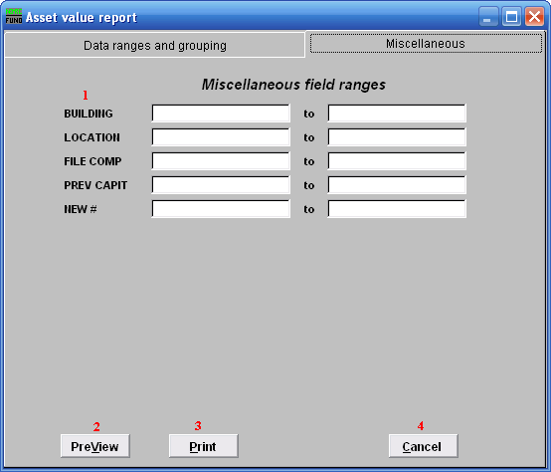
- Miscellaneous field ranges: These fields are user defined in “I. Installation” off the Main Menu.

- PreView: Click this button to preview. Refer to GENERAL PREVIEW for more information.

- Print: Click this button to print. Refer to GENERAL PRINTING for more information.

- Cancel: Click “Cancel” to cancel and return to the previous screen.

